**Student’s Name:**

**Roll Number:**

**Mobile No:**

**Branch:**

# a.

|  |  |  |
| --- | --- | --- |
|  | **Prediction Outcome** | |
| **True Label** | 100 | 200 |
| 300 | 600 |

Figure 1 KNN Confusion Matrix for K = 1

|  |  |  |
| --- | --- | --- |
|  | **Prediction Outcome** | |
| **True Label** | 100 | 200 |
| 300 | 600 |

Figure 2 KNN Confusion Matrix for K = 3

|  |  |  |
| --- | --- | --- |
|  | **Prediction Outcome** | |
| **True Label** | 100 | 200 |
| 300 | 600 |

Figure 3 KNN Confusion Matrix for K = 5

**b.**

Table 1 KNN Classification Accuracy for K = 1, 3 and 5

|  |  |
| --- | --- |
| **K** | **Classification**  **Accuracy (in %)** |
| 1 |  |
| 3 |  |
| 4 |  |

# Inferences:

1. The highest classification accuracy is obtained with K =.
2. Infer whether increasing the value of K increases/decreases the prediction accuracy.
3. State a suitable reason why increasing the value of K increases/decreases the prediction accuracy.
4. As the classification accuracy increases/decreases with the increase in value of K infer does the number of diagonal elements increase/decrease.
5. State the reason for increase/decrease in diagonal elements.
6. As the classification accuracy increases/decreases with the increase in value of K infer does the number of off-diagonal elements increase/decrease.
7. State the reason for increase/decrease in off-diagonal elements.
8. Inference 8 (You may add or delete the number of inferences).

**Note: Dummy values have been filled in the confusion matrix. Replace it with values obtained by you.**

# a.

|  |  |  |
| --- | --- | --- |
|  | **Prediction Outcome** | |
| **True Label** | 100 | 200 |
| 300 | 600 |

Figure 4 KNN Confusion Matrix for K = 1 post data normalization

|  |  |  |
| --- | --- | --- |
|  | **Prediction Outcome** | |
| **True Label** | 100 | 200 |
| 300 | 600 |

Figure 5 KNN Confusion Matrix for K = 3 post data normalization

|  |  |  |
| --- | --- | --- |
|  | **Prediction Outcome** | |
| **True Label** | 100 | 200 |
| 300 | 600 |

Figure 6 KNN Confusion Matrix for K = 5 post data normalization

**b.**

Table 2 KNN Classification Accuracy for K = 1, 3 and 5 post data normalization

|  |  |
| --- | --- |
| **K** | **Classification**  **Accuracy (in %)** |
| 1 |  |
| 3 |  |
| 5 |  |

# Inferences:

1. Infer whether data normalization increases/decreases classification accuracy.
2. State the reason for increase/decrease in classification accuracy after data normalization.
3. The highest classification accuracy is obtained with K =.
4. Infer whether increasing the value of K increases/decreases the prediction accuracy.
5. State a suitable reason why increasing the value of K increases/decreases the prediction accuracy.
6. As the classification accuracy increases/decreases with the increase in value of K infer does the number of diagonal elements increase/decrease.
7. State the reason for increase/decrease in diagonal elements.
8. As the classification accuracy increases/decreases with the increase in value of K infer does the number of off-diagonal elements increase/decrease.
9. State the reason for increase/decrease in off-diagonal elements.

**Note: Dummy values have been filled in the confusion matrix. Replace it with values obtained by you.**

|  |  |  |
| --- | --- | --- |
|  | **Prediction Outcome** | |
| **True Label** | 100 | 200 |
| 300 | 600 |

Figure 7 Confusion Matrix obtained from Bayes Classifier

The classification accuracy obtained from Bayes Classifier is %.

Table 3 Mean for class 0 and class 1

|  |  |  |  |
| --- | --- | --- | --- |
| **S. No.** | **Attribute Name** | **Mean** | |
| **Class 0** | **Class 1** |
|  | X_Minimum |  |  |
|  | X_Maximum |  |  |
|  | Y_Minimum |  |  |
|  | Y_Maximum |  |  |
|  | Pixels_Areas |  |  |
|  | X_Perimeter |  |  |
|  | Y_Perimeter |  |  |
|  | Sum_of_Luminosity |  |  |
|  | Minimum_of_Luminosity |  |  |
|  | Maximum_of_Luminosity |  |  |
|  | Length_of_Conveyer |  |  |
|  | TypeOfSteel_A300 |  |  |
|  | TypeOfSteel_A400 |  |  |
|  | Steel_Plate_Thickness |  |  |
|  | Edges_Index |  |  |
|  | Empty_Index |  |  |
|  | Square_Index |  |  |
|  | Outside_X_Index |  |  |
|  | Edges_X_Index |  |  |
|  | Edges_Y_Index |  |  |
|  | Outside_Global_Index |  |  |
|  | LogOfAreas |  |  |
|  | Log_X_Index |  |  |
|  | Log_Y_Index |  |  |
|  | Orientation_Index |  |  |
|  | Luminosity_Index |  |  |
|  | SigmoidOfAreas |  |  |

In Fig. 8 and 9 representing covariance matrices for class 0 and class 1 respectively the column numbers and row numbers correspond to attribute with serial number as in Table 3.

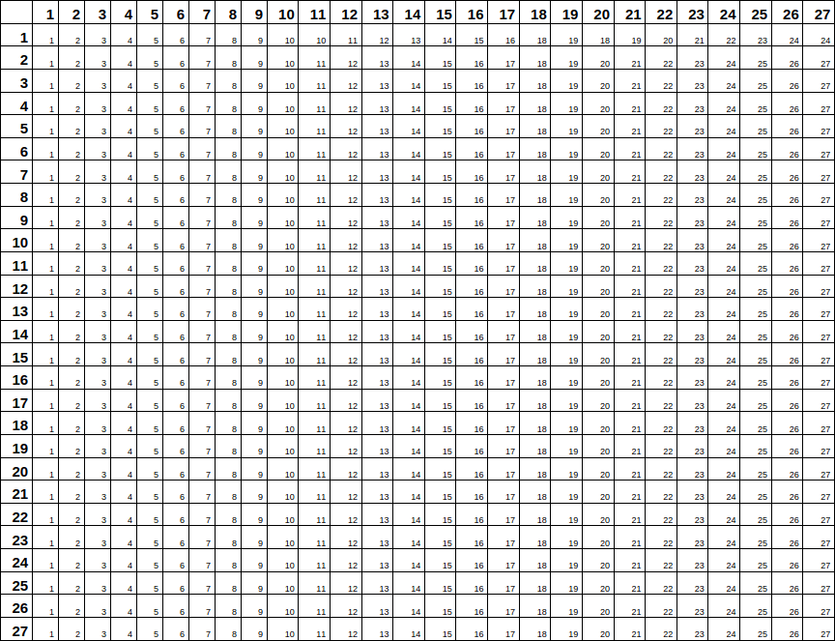

Figure 8: Covariance matrix for class 0



Figure 9: Covariance matrix for class 1

# Inferences:

1. Write the accuracy of Bayes Classifier and state reason why it is lesser / greater than previous classification approaches.
2. Infer from covariance matrix the nature of values along the diagonal. State the reason.
3. Infer from off-diagonal elements the covariance between attributes. Write 2 pair of attributes with maximum and 2 pair of attributes with minimum covariance.

**Note: Please write diagonal values of covariance matrices in boldface. On moodle, the template for covariance matrix is uploaded as .docx and .xlsx format. Fill in the values and change the covariance matrices into images. Insert the covariance matrices as images to the document.**

Table 4 Comparison between classifiers based upon classification accuracy

|  |  |  |
| --- | --- | --- |
| **S. No.** | **Classifier** | **Accuracy (in %)** |
|  | KNN |  |
|  | KNN on normalized data |  |
|  | Bayes |  |

# Inferences:

1. Mention the classifiers with highest and lowest accuracy.
2. Arrange the classifiers in ascending order of classification accuracy. Classifier a < Classifier b < Classifier c < Classifier d < Classifier e.
3. State the reasons behind Inference 1 and 2.

**Guidelines for Report (Delete this while you submit the report):**

* **The plot/graph/figure/table should be centre justified with sequence number and caption.**
* **Inferences should be written as a numbered list.**
* **Use specific and technical terms to write inferences.**
* **Values observed/calculated should be rounded off to three decimal places.**
* **The quantities which have units should be written with units.**
* **Please fit a confusion matrix/covariance matrix /table in one page only.**